**The Why’s and What’s of Kubernetes**

* **Introduction:**

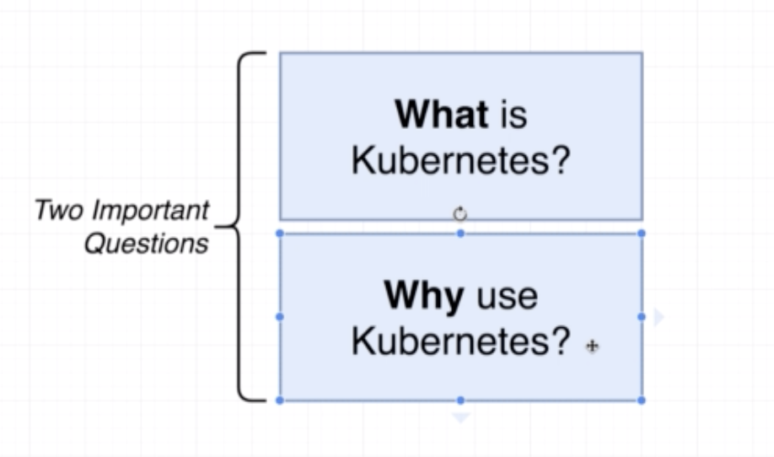

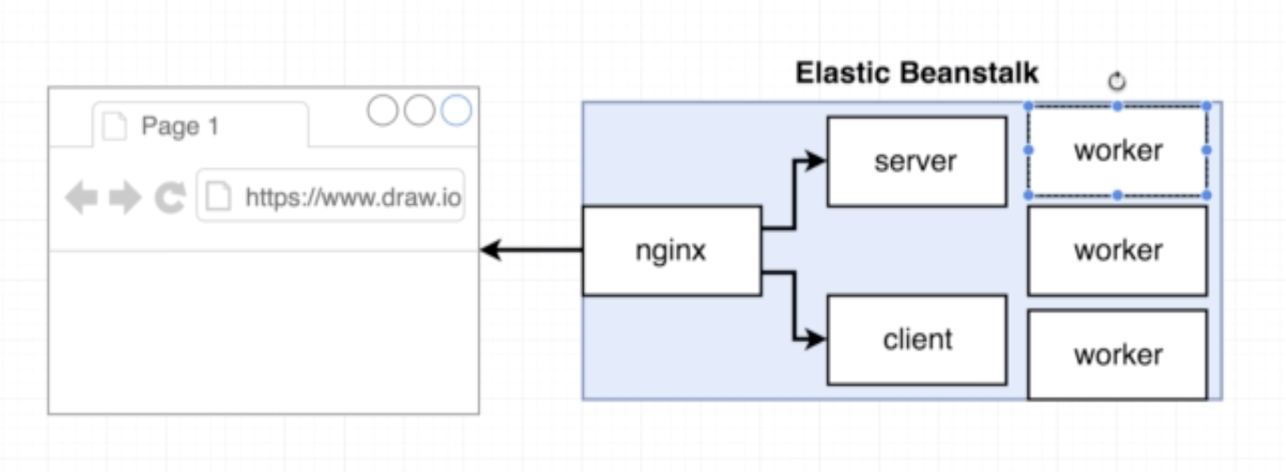

How will we increase the number of instances for a specific container (worker) in case of increasing traffic?

Problem with Elasticbeanstalk is it will not be able to increase the increase the single container alone, but it can increase complete set of application instances as shown below.

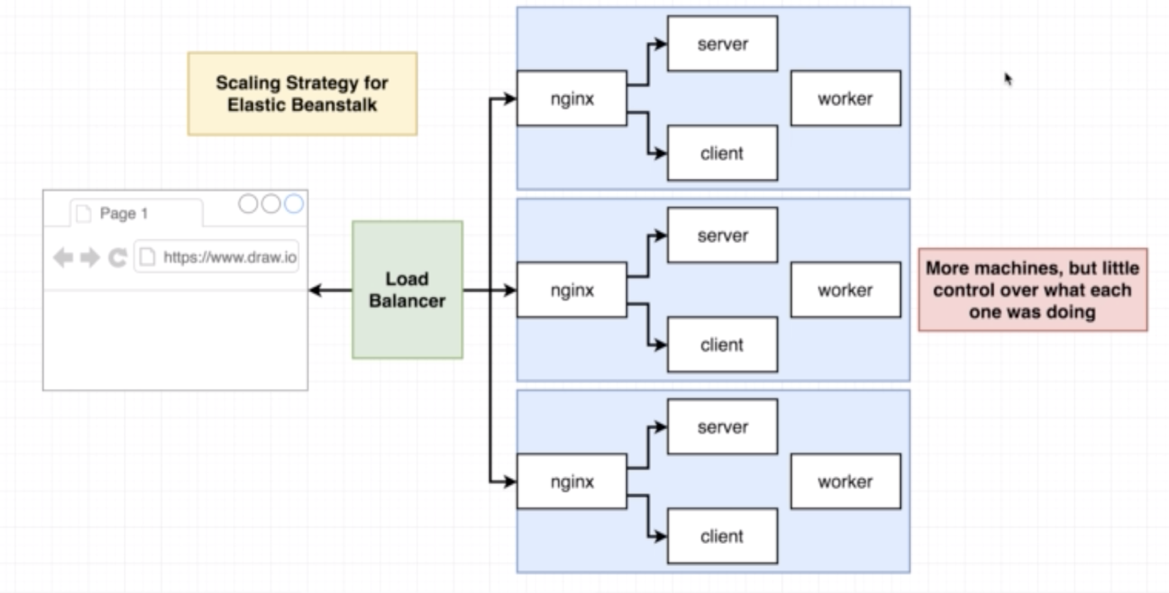

Instead of increasing all the containers for a given application, it will be nice if we have a feature to increase the specific container (worker) alone as below.

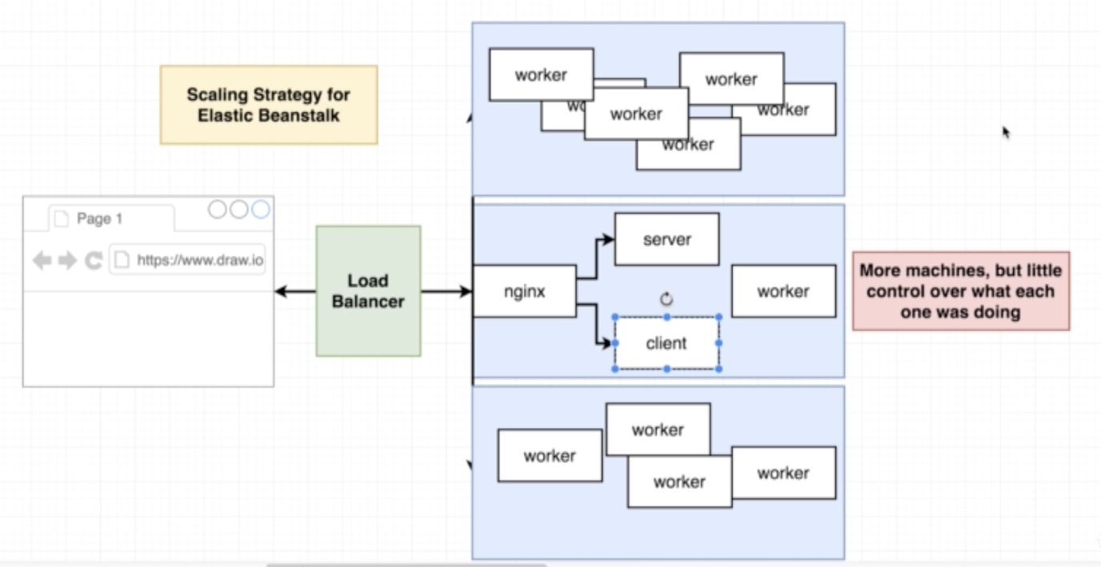

Kubernetes:

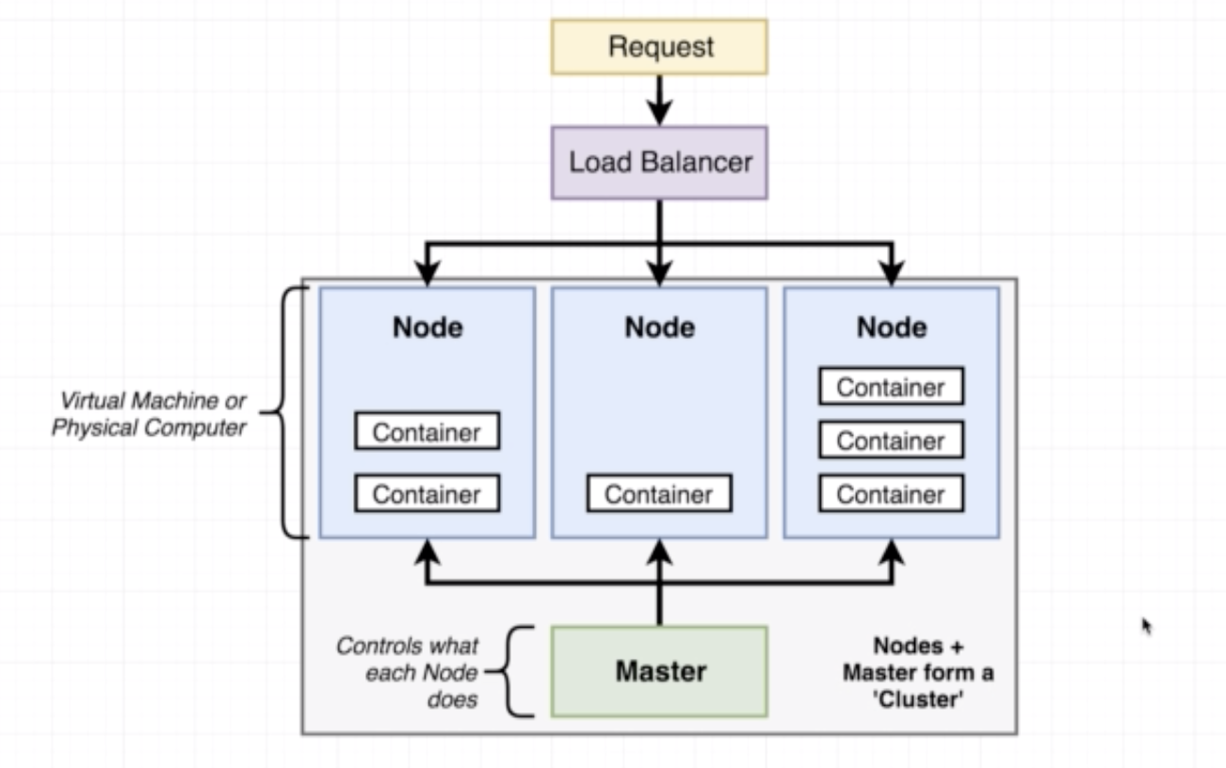

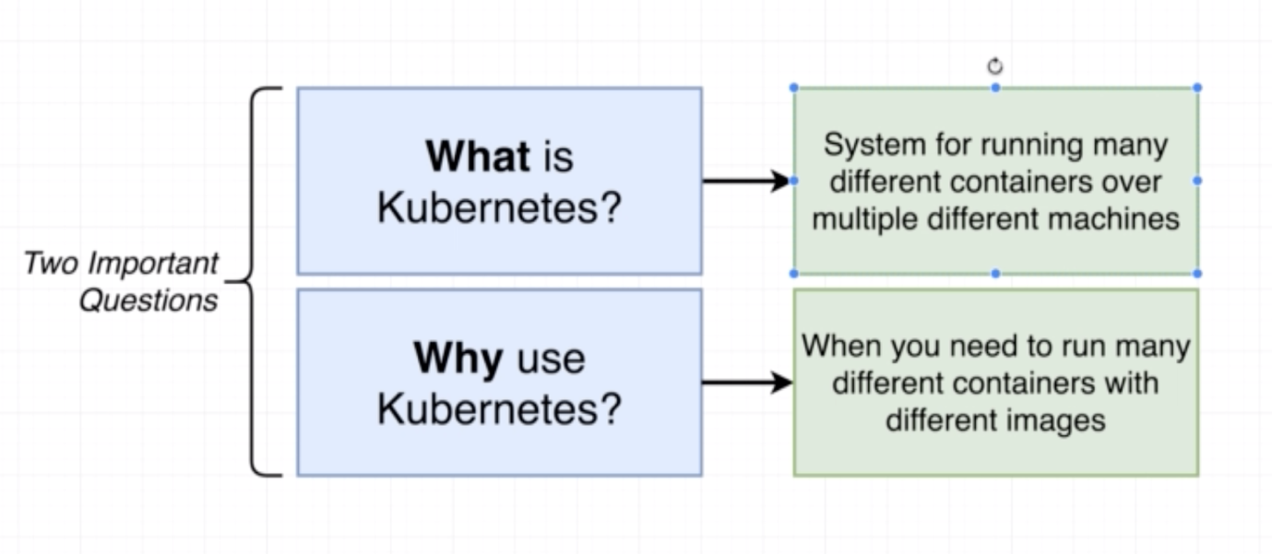

* **Kubernetes in Development & Production:**

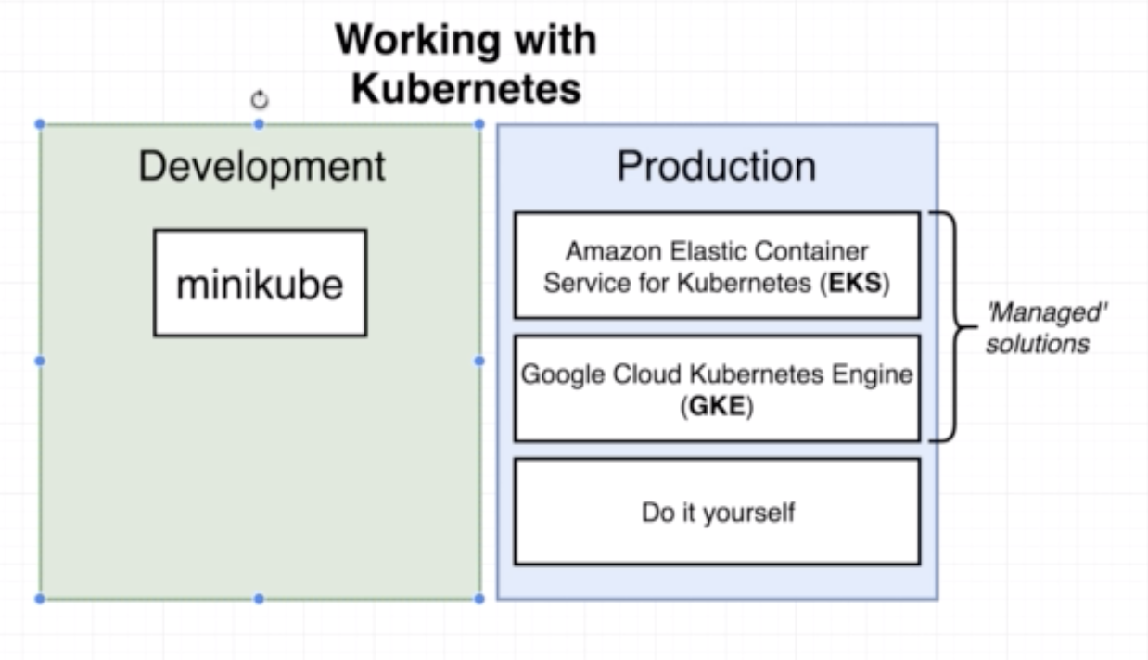

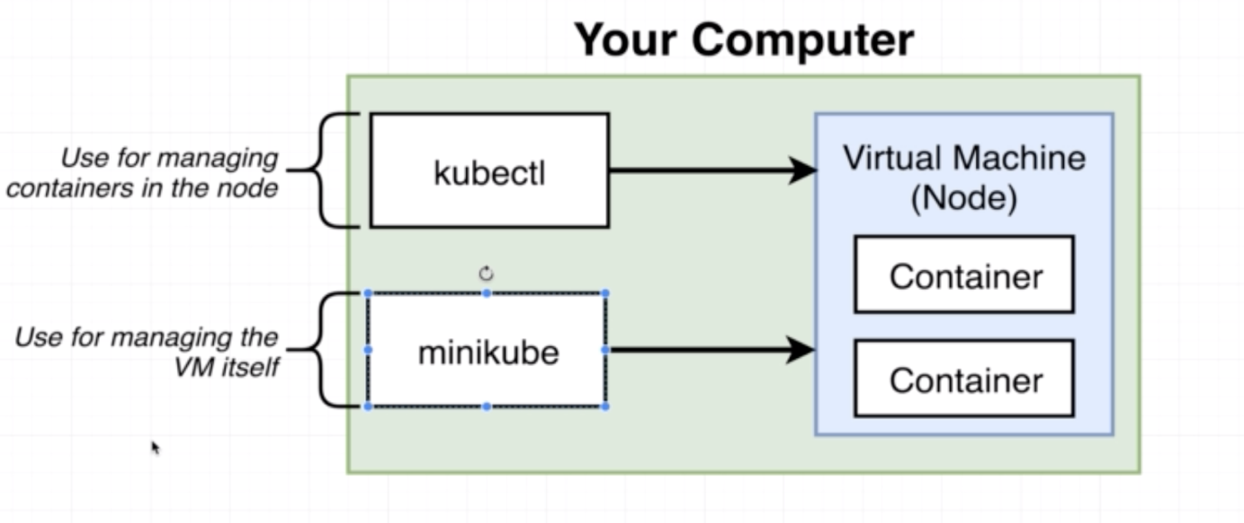

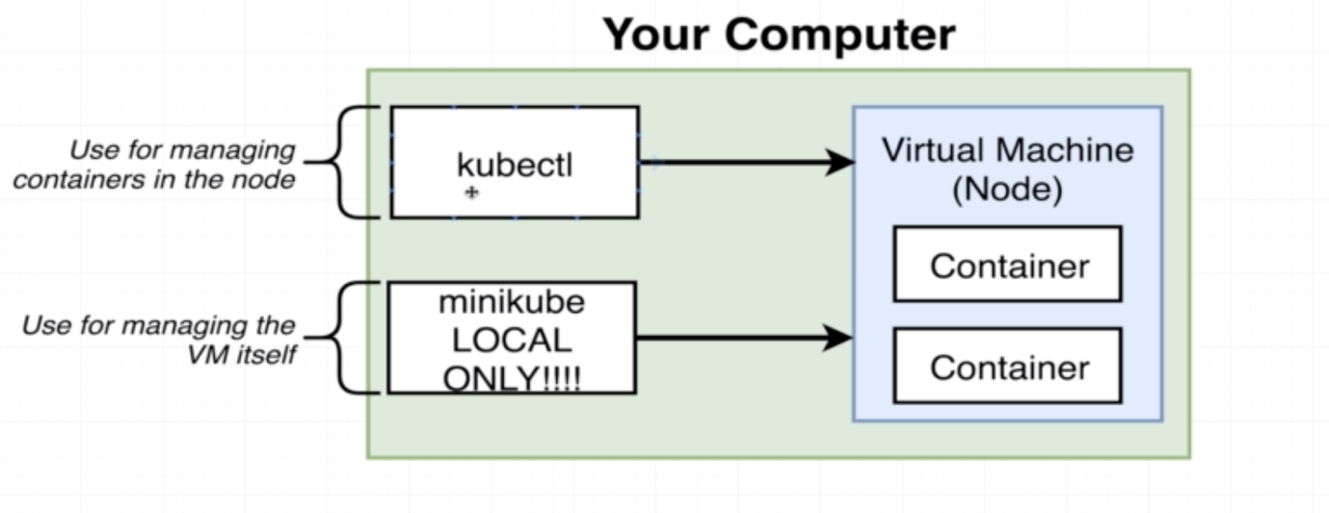

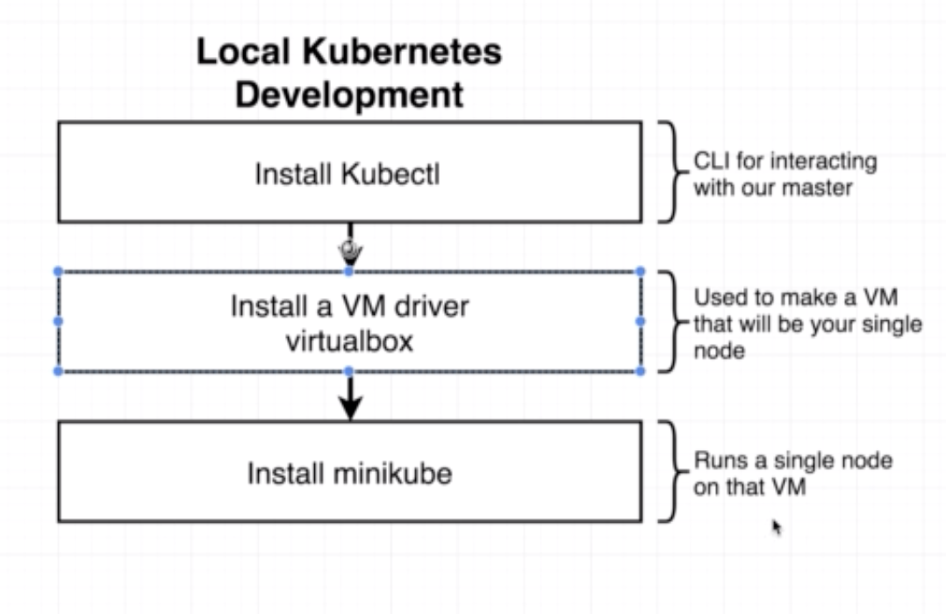

* **Minikube Setup on MacOS:**

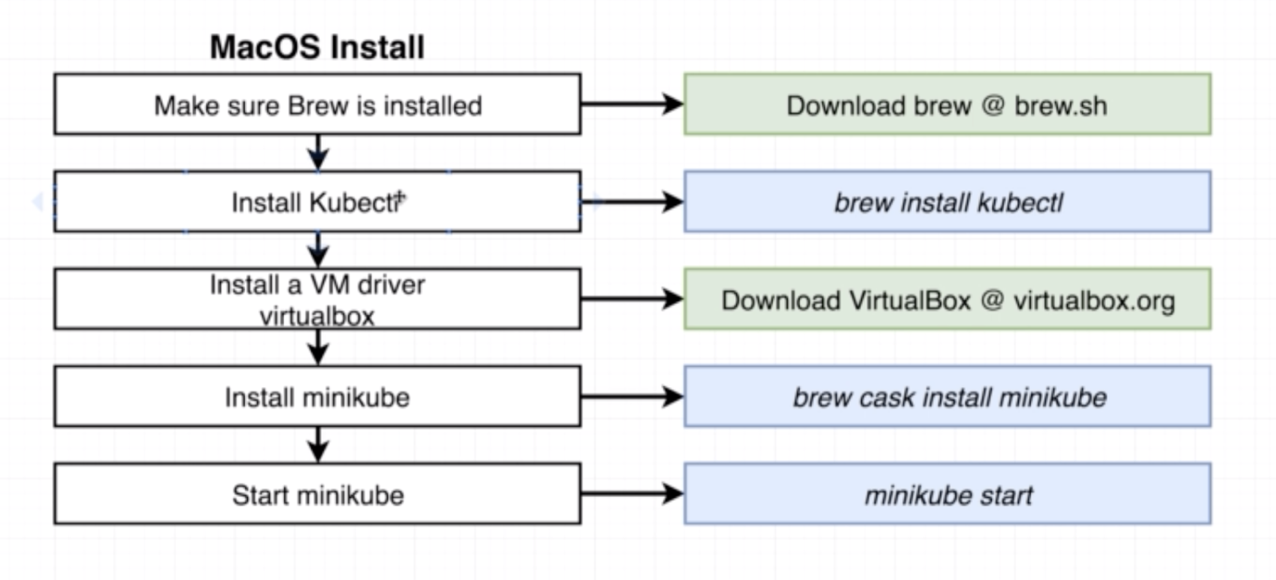

Commands to start minikube:

export NO_PROXY=localhost,127.0.0.1,10.96.0.0/12,192.168.99.0/24,192.168.39.0/24

minikube start -- driver=virtualbox

Once everything is successful, you must see a message like below

😄 minikube v1.14.0 on Darwin 10.14.6

✨ Using the virtualbox driver based on user configuration

👍 Starting control plane node minikube in cluster minikube

🔥 Creating virtualbox VM (CPUs=2, Memory=4000MB, Disk=20000MB) ...

🌐 Found network options:

▪ NO_PROXY=localhost,127.0.0.1,10.96.0.0/12,192.168.99.0/24,192.168.39.0/24

❗ This VM is having trouble accessing https://k8s.gcr.io

💡 To pull new external images, you may need to configure a proxy: https://minikube.sigs.k8s.io/docs/reference/networking/proxy/

🐳 Preparing Kubernetes v1.19.2 on Docker 19.03.12 ...

▪ env NO_PROXY=localhost,127.0.0.1,10.96.0.0/12,192.168.99.0/24,192.168.39.0/24

> kubectl.sha256: 65 B / 65 B [--------------------------] 100.00% ? p/s 0s

> kubeadm.sha256: 65 B / 65 B [--------------------------] 100.00% ? p/s 0s

> kubelet.sha256: 65 B / 65 B [--------------------------] 100.00% ? p/s 0s

> kubeadm: 37.30 MiB / 37.30 MiB [-----------] 100.00% 495.04 KiB p/s 1m17s

> kubectl: 41.01 MiB / 41.01 MiB [-----------] 100.00% 511.22 KiB p/s 1m22s

> kubelet: 104.88 MiB / 104.88 MiB [----------] 100.00% 845.82 KiB p/s 2m7s

🔎 Verifying Kubernetes components...

🌟 Enabled addons: storage-provisioner, default-storageclass

❗ /usr/local/bin/kubectl is version 1.14.8, which may have incompatibilites with Kubernetes 1.19.2.

💡 Want kubectl v1.19.2? Try 'minikube kubectl -- get pods -A'

🏄 Done! kubectl is now configured to use "minikube" by default

localhost:~ spandiyan$ minikube ip

192.168.99.101

And you must see the minikube instance running in virtual box as shown below.

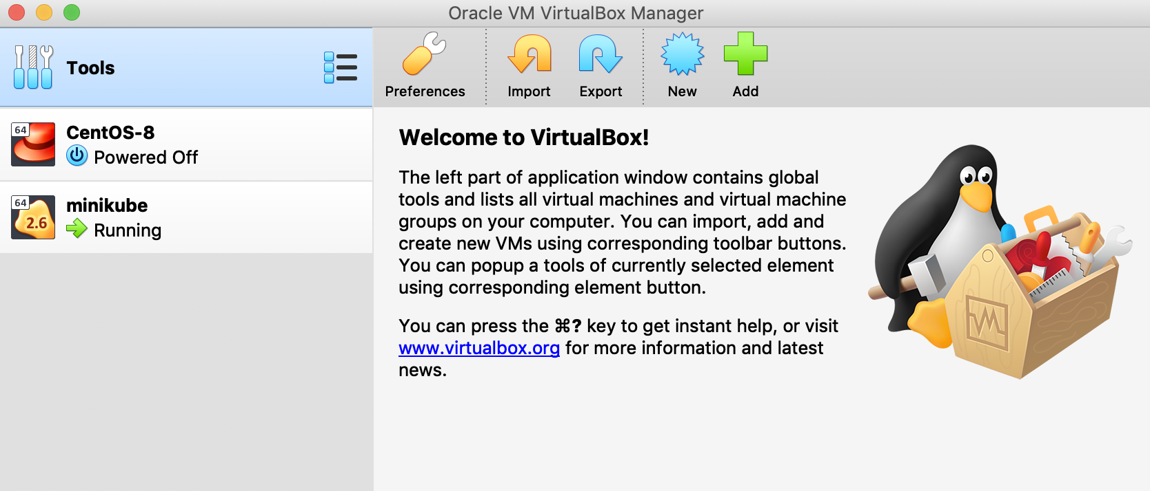

Post this you can use below command to check the status of minikube and the cluster:

minikube status

if everything works fine then you will get a message as shown below.

minikube

type: Control Plane

host: Running

kubelet: Running

apiserver: Running

kubeconfig: Configured

kubectl cluster-info

Kubernetes master is running at https://192.168.99.101:8443

KubeDNS is running at https://192.168.99.101:8443/api/v1/namespaces/kube-system/services/kube-dns:dns/proxy

* **Mapping Existing Knowledge:**

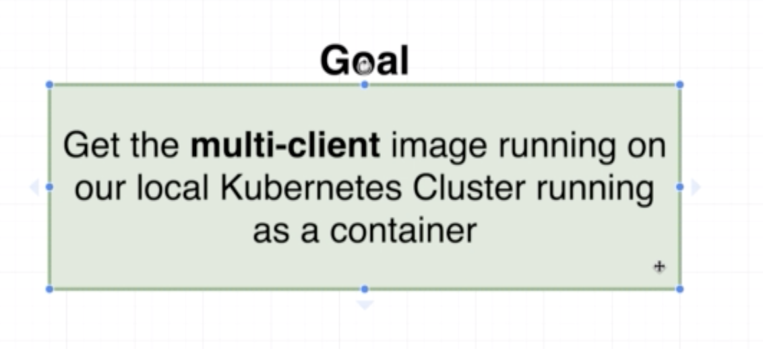

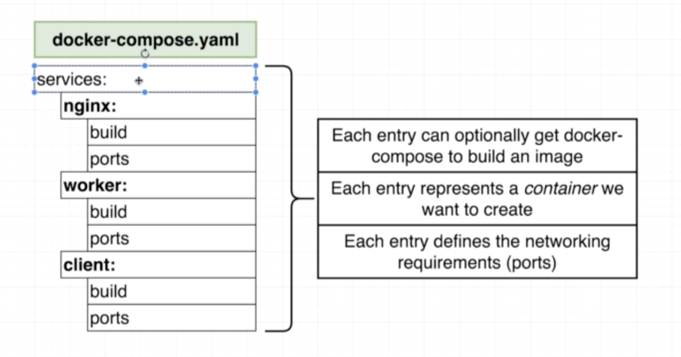

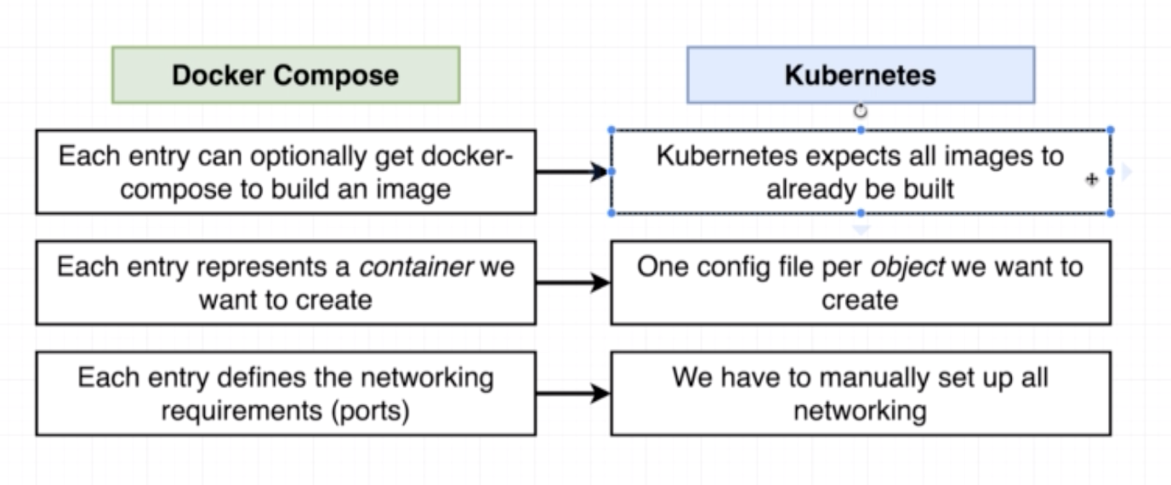

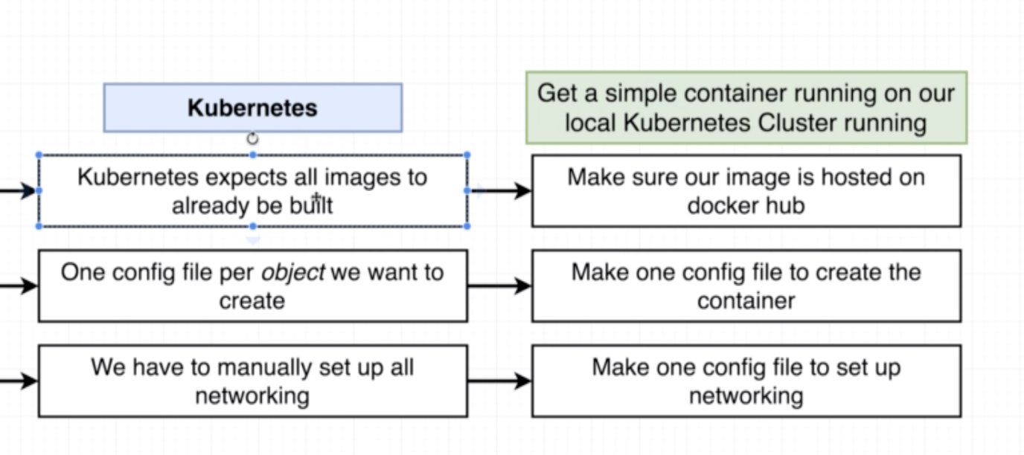

* **Adding Configuration Files:**

Add following files in a separate directory named “simplek8s”

client-pod.yaml:

apiVersion: v1

kind: Pod

metadata:

name: client-pod

labels:

component: web

spec:

containers:

- name: client

image: stephengrider/multiclient

ports:

- containerPort: 3000

Client-node-port.yaml:

apiVersion: v1

kind: Service

metadata:

name: client-node-port

spec:

type: NodePort

ports:

- ports: 3050

targetPort: 3000

nodePort: 31515

selector:

component: web

* **Object Types and API Versions:**

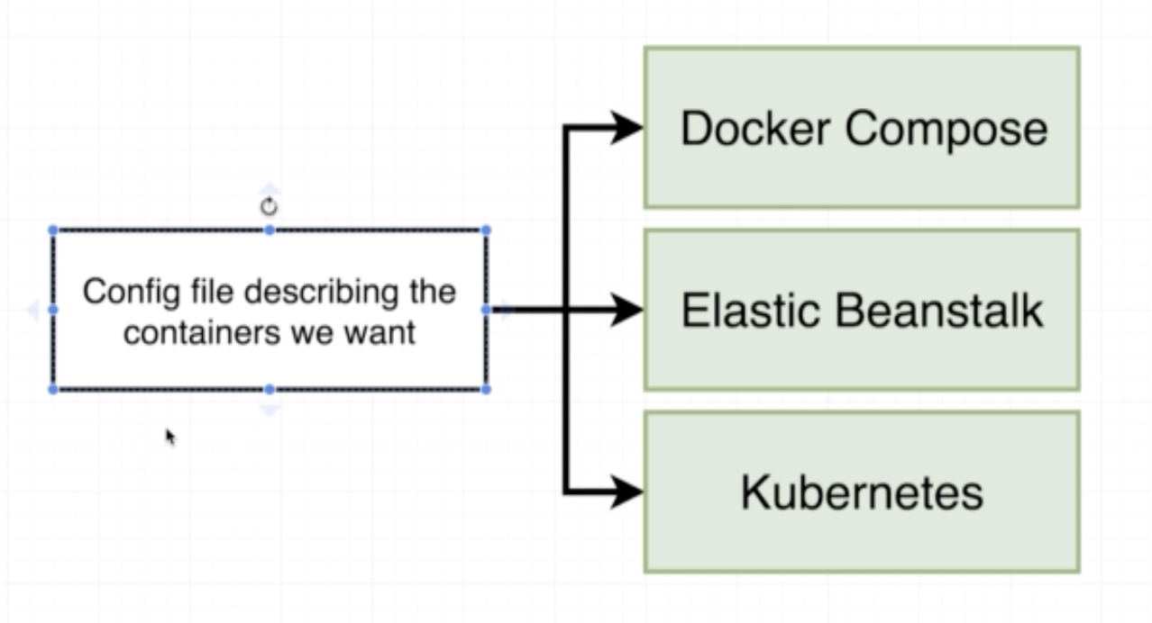

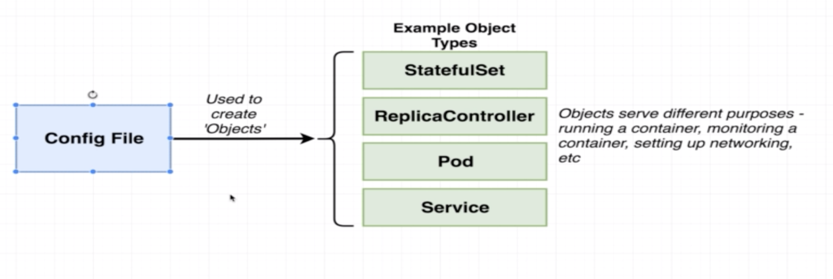

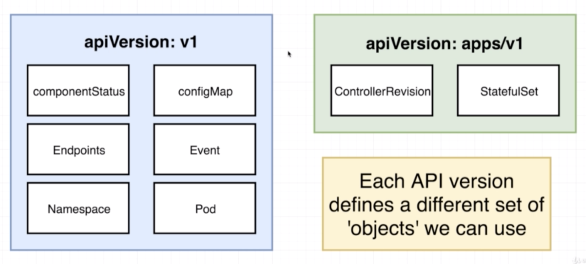

* **Running Containers in Pods:**

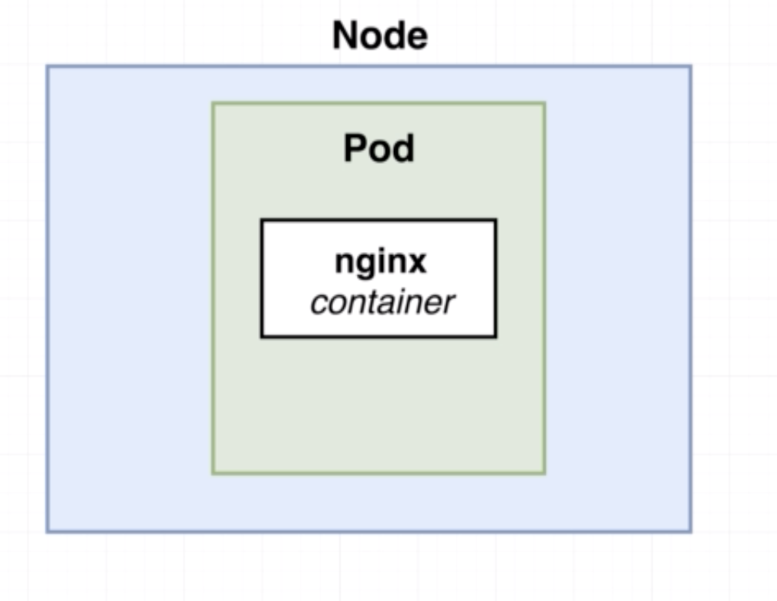

**A Pod can run one or more container inside of it.**

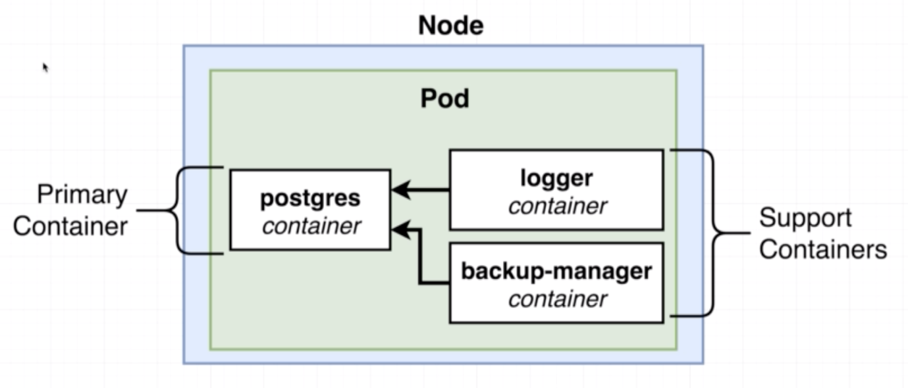

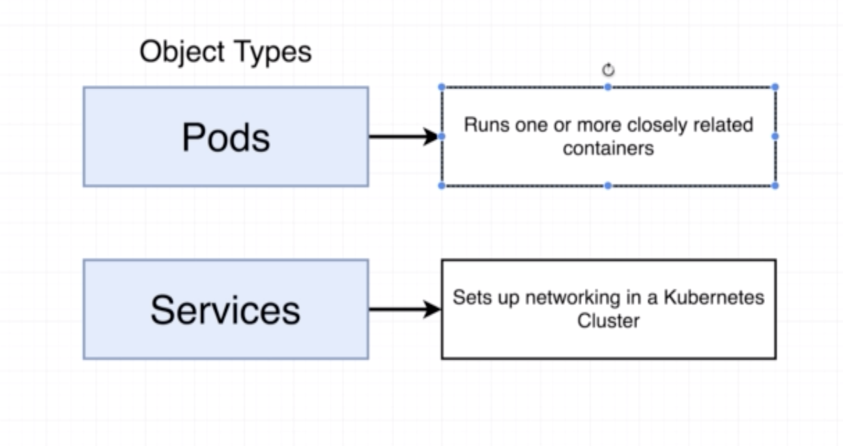

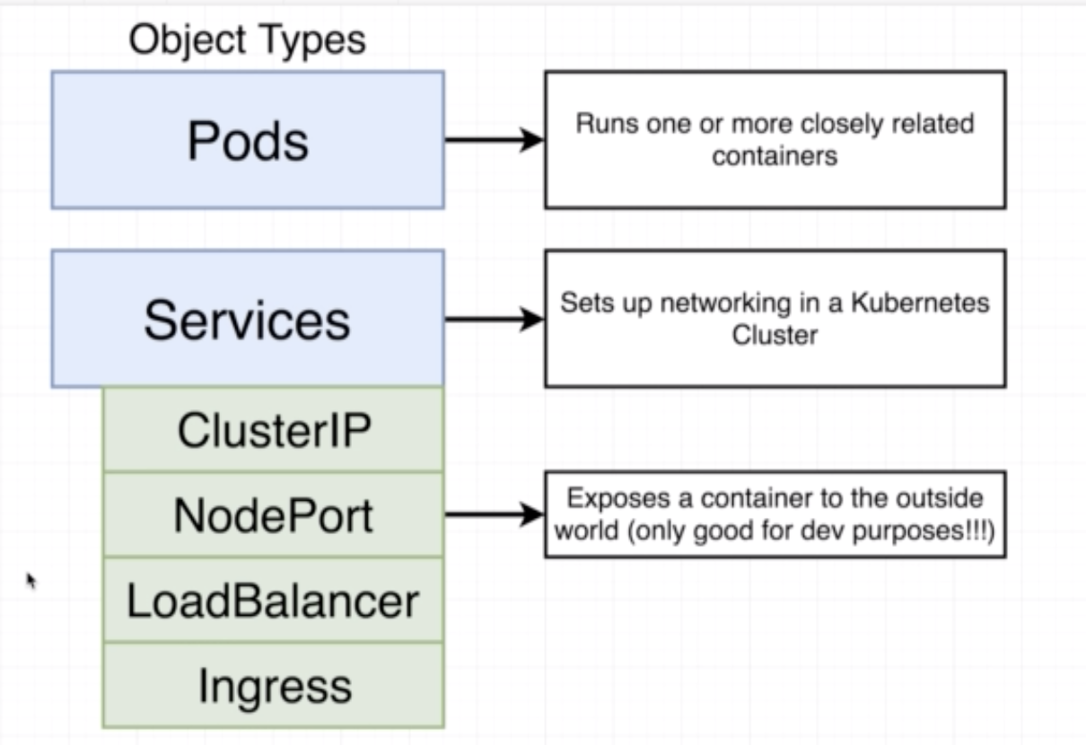

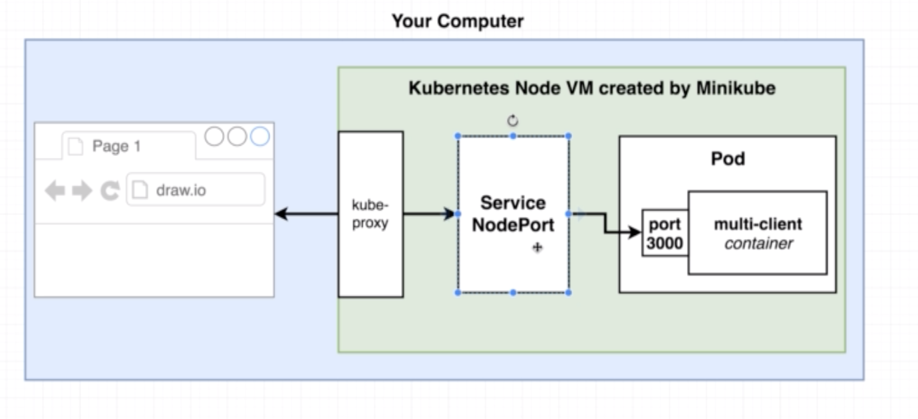

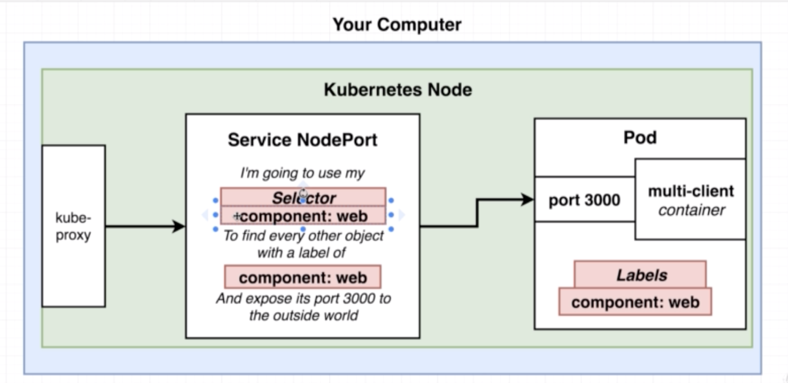

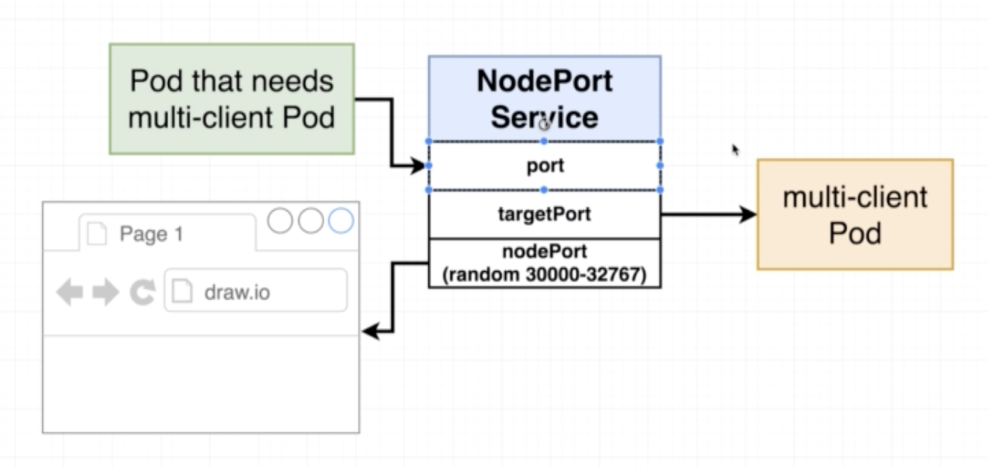

* **Connecting to Running Containers:**

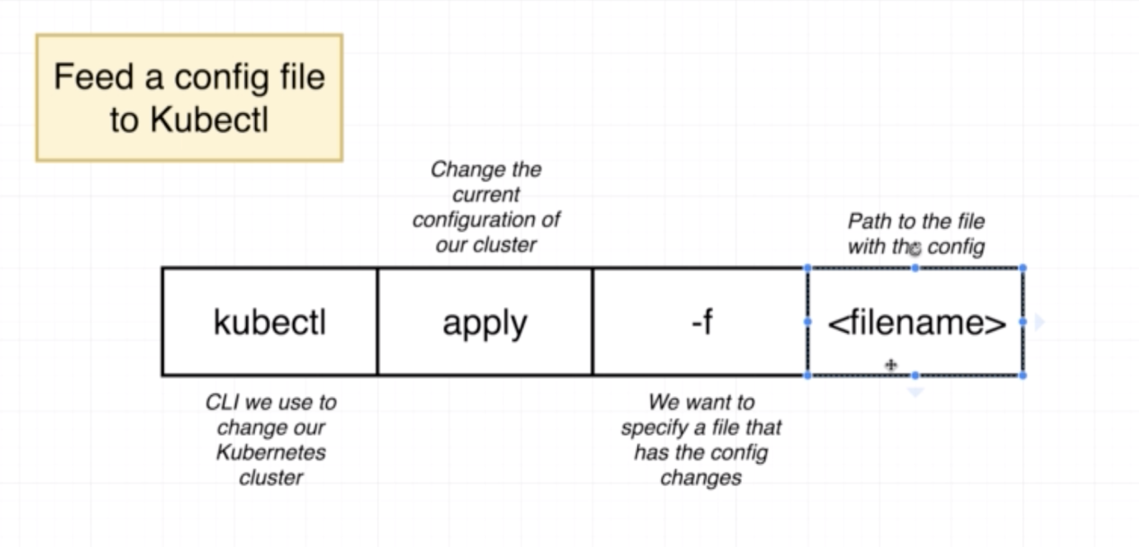

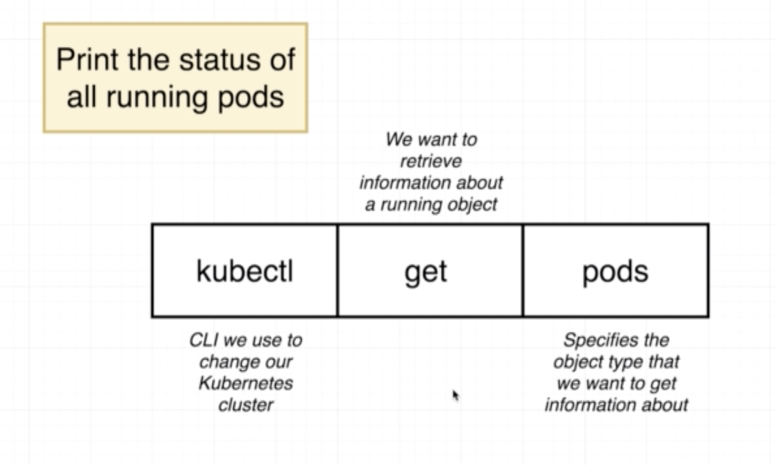

**kubectl get pods**

**kubectl get services**

**kubectl delete pods pod_name**

**To run docker commands inside minikube node.**

**eval $(minikube docker-env)**

* **The Entire Deployment Process:**

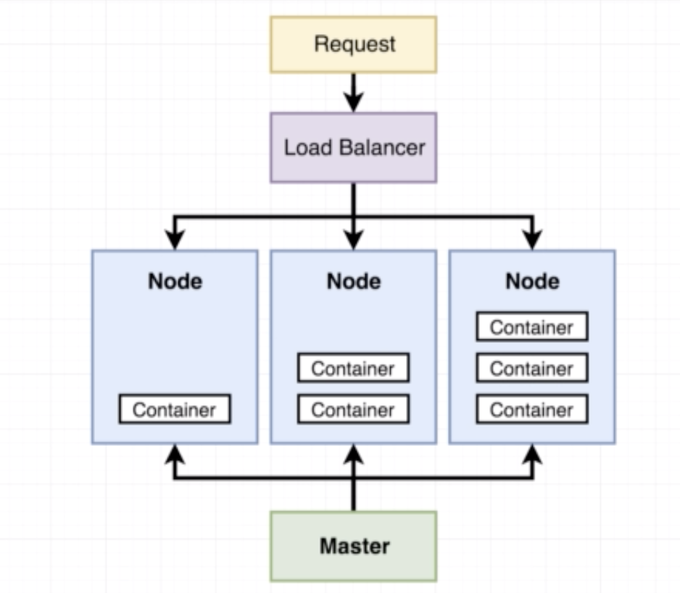

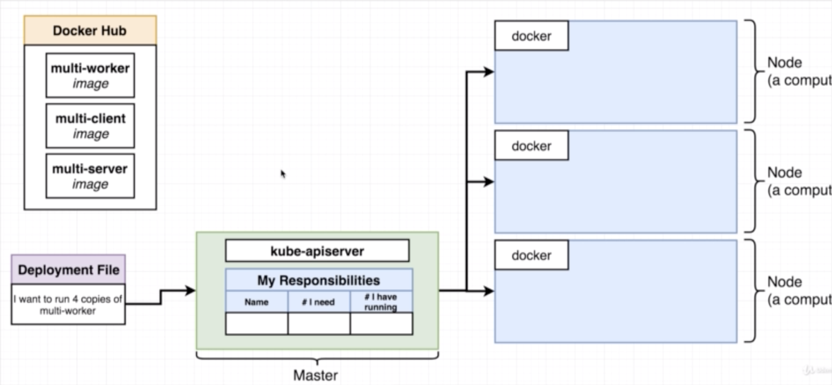

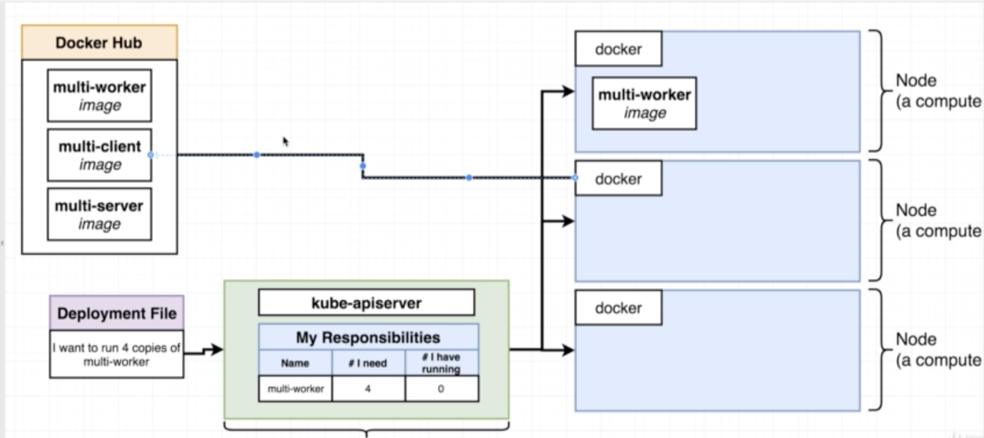

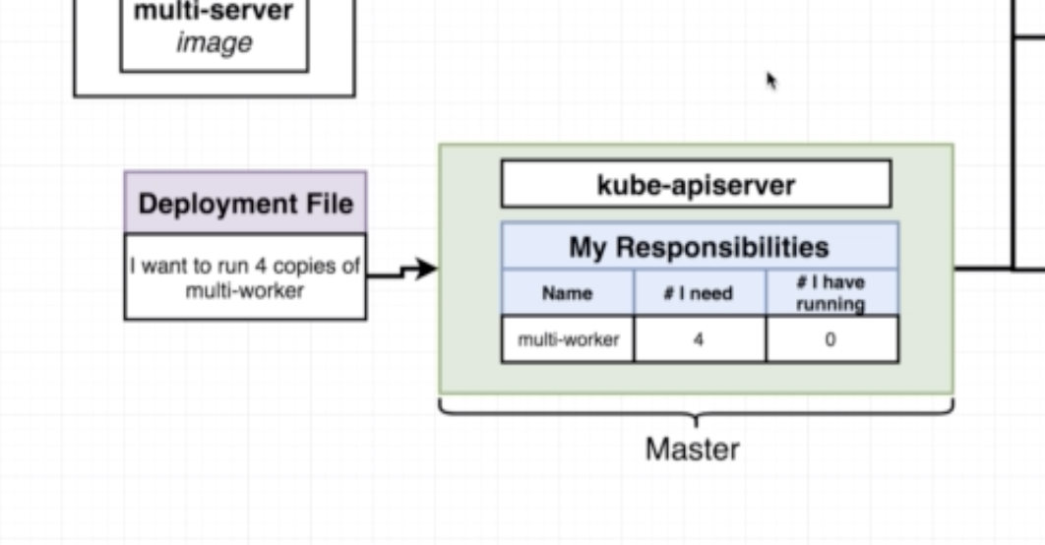

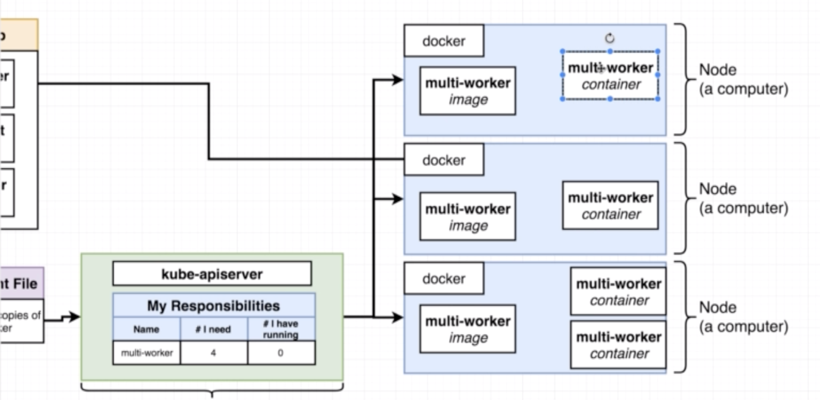

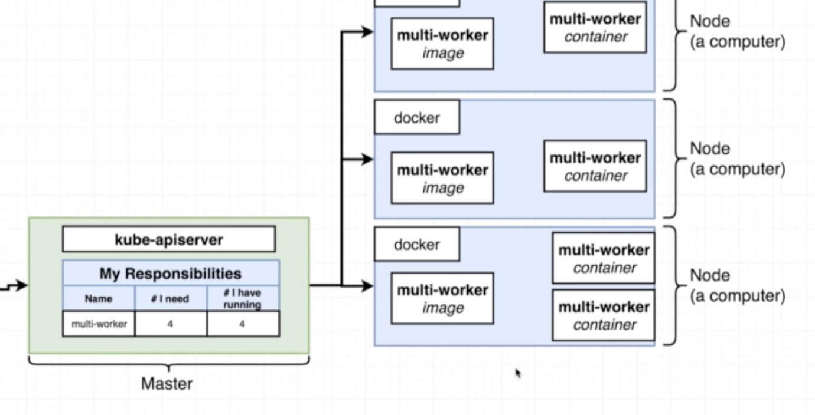

* **Imperative vs Declarative Deployments:**

